|  |  |  |
| --- | --- | --- |
| **Team Members** | **Roll No** | **PRN** |
| Mohit M. Deshpande | 231069 | 22120062 |
| Om S. Bhavsar | 231070 | 22120084 |
| **Subject:** IT-W-II | | |
| **Batch:** A3 | | |

**Colour detection using OpenCV**

**Introduction:**

In real life colour detection gets used in many fields like PHARMACEUTICAL / FOOD PROCESSING,

Detecting register marks on a packaging sheet, in industry products have specific colour code upon that   
they got differentiated and for all of this the colour detection get used.

For that we have created **‘COLOUR DETECTION USING OPENCV’** in this we are going to use OpenCV for detection of colour in other words we are going to use Camera to detect the colour in front of the camera, we have to just take the object in front of camera then the object’s colour. We are going to use RGB values for detecting the colour and also the name will be given for that particular colour.

Here some applications of Colour detection:

* Colour mark detection. PHARMACEUTICAL AND FOOD PROCESSING / PACKAGING.
* Detecting register marks on a packaging sheet. PHARMACEUTICAL AND FOOD PROCESSING / PACKAGING.
* Colour mark detection of screw head. AUTOMOBILES.
* Distinguishing colour when there is background object.

**Data used:**

**OpenCV library:**

For this Project we are going to use OpenCV as our main library which can be use for image editing and live video editing, OpenCV gives the image and video fame by frame and gives us functions that can be used for draw the video or process the video.

**Numpy:**

Numpy for flipping the image or frame because in default the image coming from the camera is mirror image.

**Imutils:**

Imutils for resizing the frame. It gives functions for resizing the frames.it is also get used for reading the video stream in our case it is web cam of our laptop.

**Pandas:**

We are Pandas for reading the CSV file. Because we are going to give the name of the colour the CSV file has the name of the colour according to their RGB values.

**CSV file:**

Here we are going to use a CSV file named **‘Colours’** which will give us the name of the colours according to the RGB values i.e Red Green Blue values. The CSV file contains the name of the every colour and their RGB values. Link below is for downloading the CSV file. We downloaded file from a github.

<https://github.com/codebrainz/color-names/blob/master/output/colors.csv>

**Implementation:**

**Code:**

import cv2

import numpy as np

import imutils

from imutils.video import VideoStream

import pandas as pd

def get_color_name(R, G, B):

minimum = 10000

for i in range(len(csv)):

# calculating the RGB values which are close to the RGB values in the CSV file.

d = abs(R - int(csv.loc[i, "R"])) + abs(G - int(csv.loc[i, "G"])) + abs(B - int(csv.loc[i, "B"]))

if d <= minimum:

minimum = d

cname = csv.loc[i, "color_name"]

return cname

index = ["color", "color_name", "hex", "R", "G", "B"]

# reading the CSV file for reading the color name

csv = pd.read_csv('colors.csv', names=index, header=None)

# starting the camera and reading video stream.

cap = VideoStream(src=0).start()

while True:

# Reading the video stream frame by frame.

frame = cap.read()

frame = np.flip(frame, axis=1)

# hsv_frame = cv2.cvtColor(frame,cv2.COLOR_BGR2HSV)

frame = imutils.resize(frame, width=640)

frame = imutils.resize(frame, height=480)

height, width, _ = frame.shape

# calculating the center of the frame.

cx = int(width / 2)

cy = int(height / 2)

# taking the center BGR values of frame.

pixel_center_bgr = frame[cy, cx]

print(pixel_center_bgr)

b, g, r = int(pixel_center_bgr[0]), int(pixel_center_bgr[1]), int(pixel_center_bgr[2])

# putting rectangle on frame for showing the color name.

cv2.rectangle(frame, (20, 20), (750, 60), (b, g, r), -1)

# getting color color name from get_color_name() function.

text = get_color_name(r, g, b) + ' R=' + str(r) + ' G=' + str(g) + ' B=' + str(b)

cv2.putText(frame, text, (50, 50), 2, 0.8, (255, 255, 255), 2, cv2.LINE_AA)

cv2.circle(frame, (cx, cy), 5, (25, 25, 25), 3)

# putting black text on rectangle if the colors are light.

if r + g + b >= 600:

cv2.putText(frame, text, (50, 50), 2, 0.8, (0, 0, 0), 2, cv2.LINE_AA)

# finally showing the whole video frame by frame.

cv2.imshow("Frame", frame)

key = cv2.waitKey(1)

if key == 113:

break

cv2.destroyAllWindows()

**Output:**

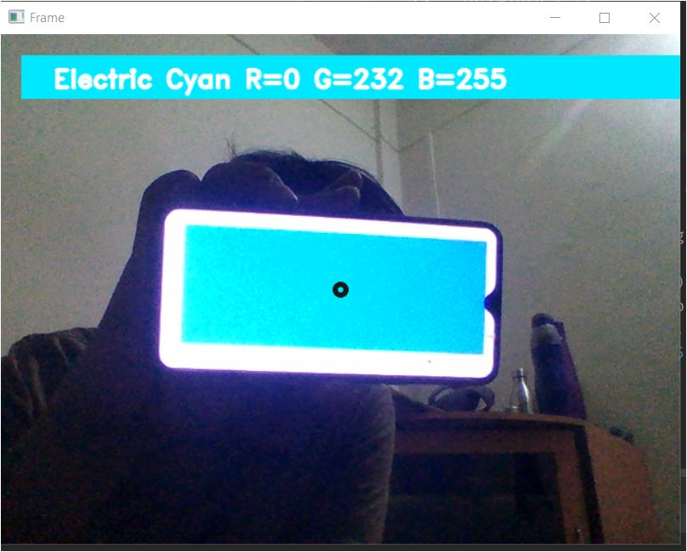

**THIS BLACK CIRCLE IS THE PIXEL POINT**

**WHERE WE ARE GOING TO PUT OUR OBJECT**

**THEN THE OBJECT’S COLOUR GETS DETECTED**

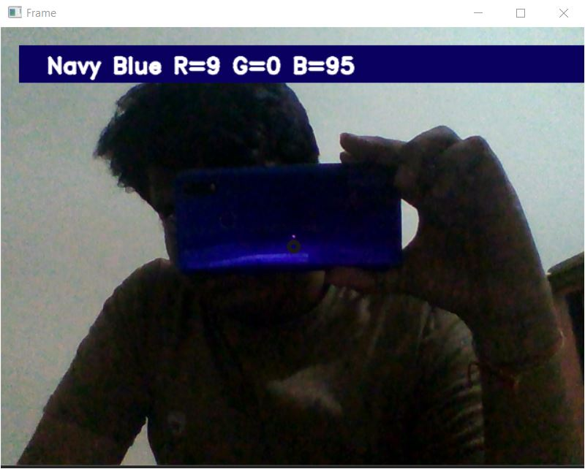

**Conclusion and Future scope:**

This helped us to learn OpenCV and use of other python libraries like Pandas ,Imutils ,Numpy for creating colour detection. Talking about future scope of this project this can be used in places where RGB colours get used like gaming rooms, for differentiating between products by there colour marking and many more this can be used where we can change colour of the room according to the Colour of the shirt which the man wearing while entering the restaurant.

**References:**

[**https://pypi.org/project/opencv-python/**](https://pypi.org/project/opencv-python/)

[**https://techvidvan.com/tutorials/detect-objects-of-similar-color-using-opencv-in-python/**](https://techvidvan.com/tutorials/detect-objects-of-similar-color-using-opencv-in-python/)

[**https://github.com/codebrainz/color-names/blob/master/output/colors.csv**](https://github.com/codebrainz/color-names/blob/master/output/colors.csv)